OVERALL PROGRAMME EVALUATION REPORT
Resource Mobilization Programme
No. of Respondents: 200
No. of Participants: 200
Response Rate: 100%
--------------------------------------------------

Faculty Reports

Annette Murunga - Developing individual action plans
Evaluation Parameter | (%) Individual Score | (%) Programme Average
Punctuality | 98 | 96
Clarity of presentation | 98 | 94
Degree of preparation | 98 | 94
Course design & org | 94 | 91
Content & methodology | 96 | 93
Quality of discussions | 98 | 94
Relevance to work | 98 | 95
Average scores | 97 | 94

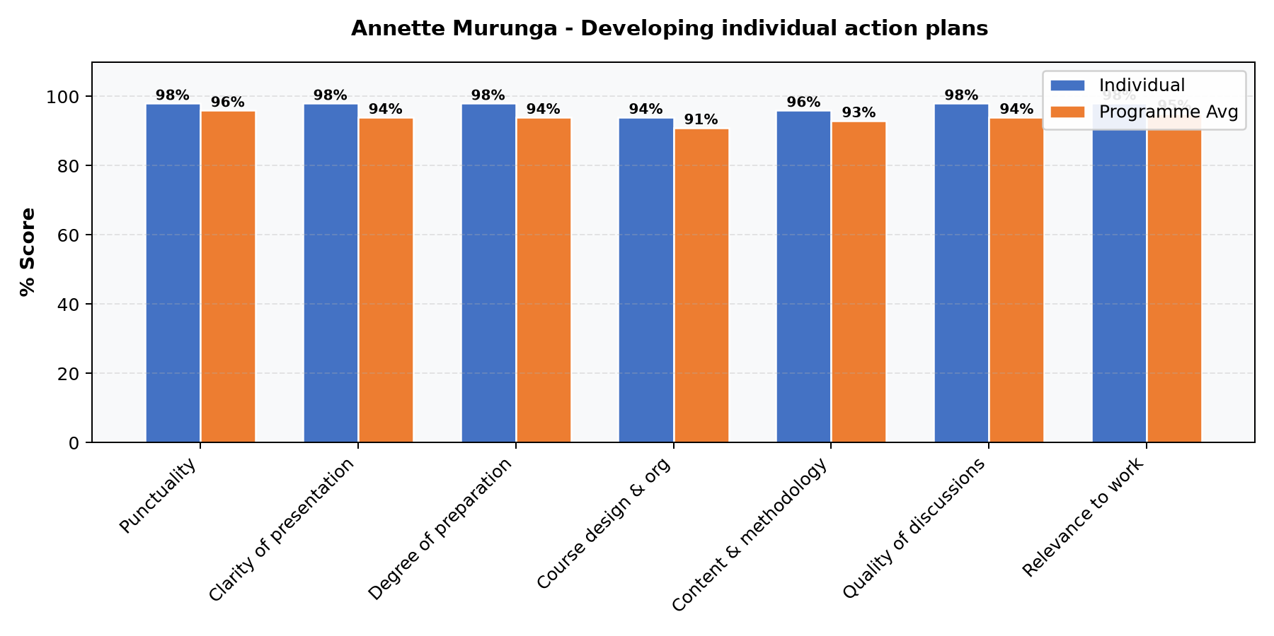

Comments & Feedback
No comments recorded.

Emmanuel Munyasia - Emerging Global development trends || Common Pitfalls in Resource Mobilization
Evaluation Parameter | (%) Individual Score | (%) Programme Average
Punctuality | 96 | 96
Clarity of presentation | 96 | 94
Degree of preparation | 98 | 94
Course design & org | 94 | 91
Content & methodology | 96 | 93
Quality of discussions | 98 | 94
Relevance to work | 98 | 95
Average scores | 97 | 94

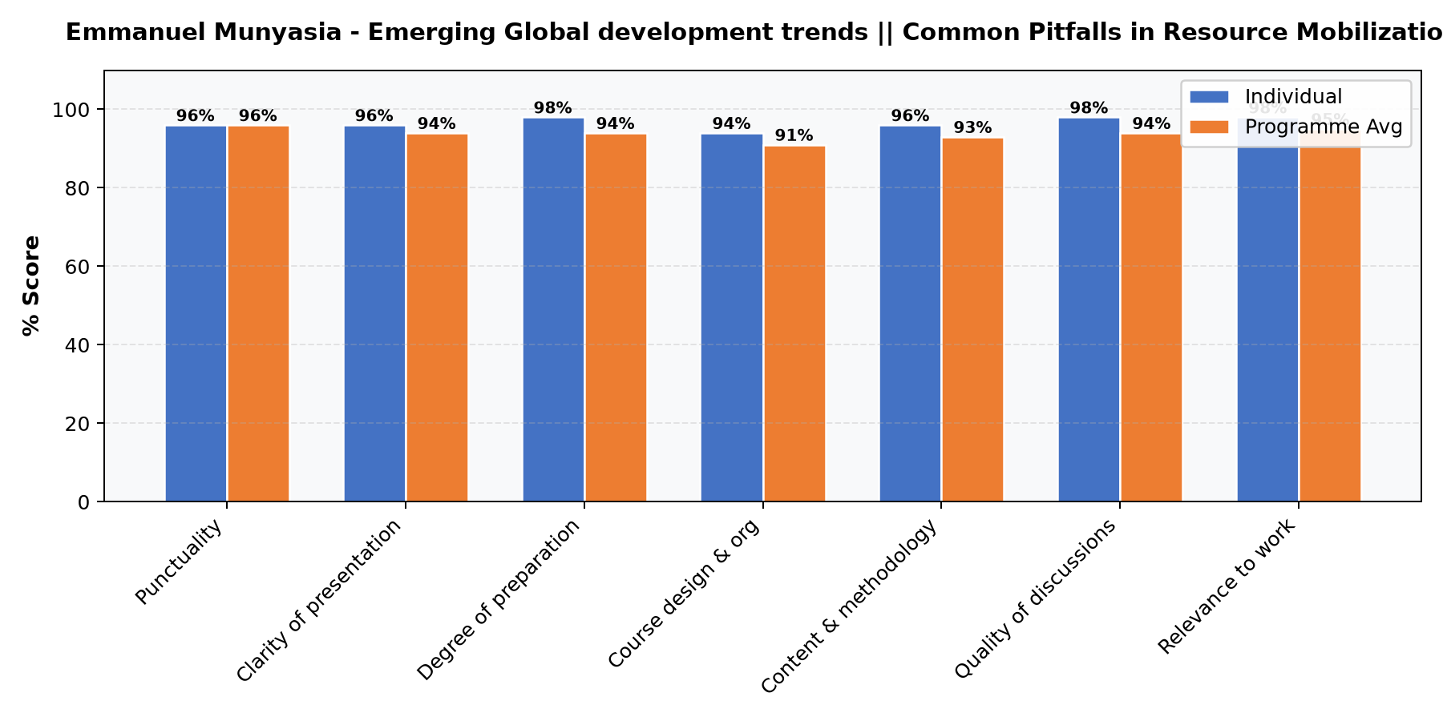

Comments & Feedback
- • Have deeper sessions on budgeting
- • Good trainers with knowledge

Annette Murunga - Introduction to Resource Mobilization
Evaluation Parameter | (%) Individual Score | (%) Programme Average
Punctuality | 92 | 96
Clarity of presentation | 88 | 94
Degree of preparation | 85 | 94
Course design & org | 87 | 91
Content & methodology | 87 | 93
Quality of discussions | 88 | 94
Relevance to work | 91 | 95
Average scores | 88 | 94

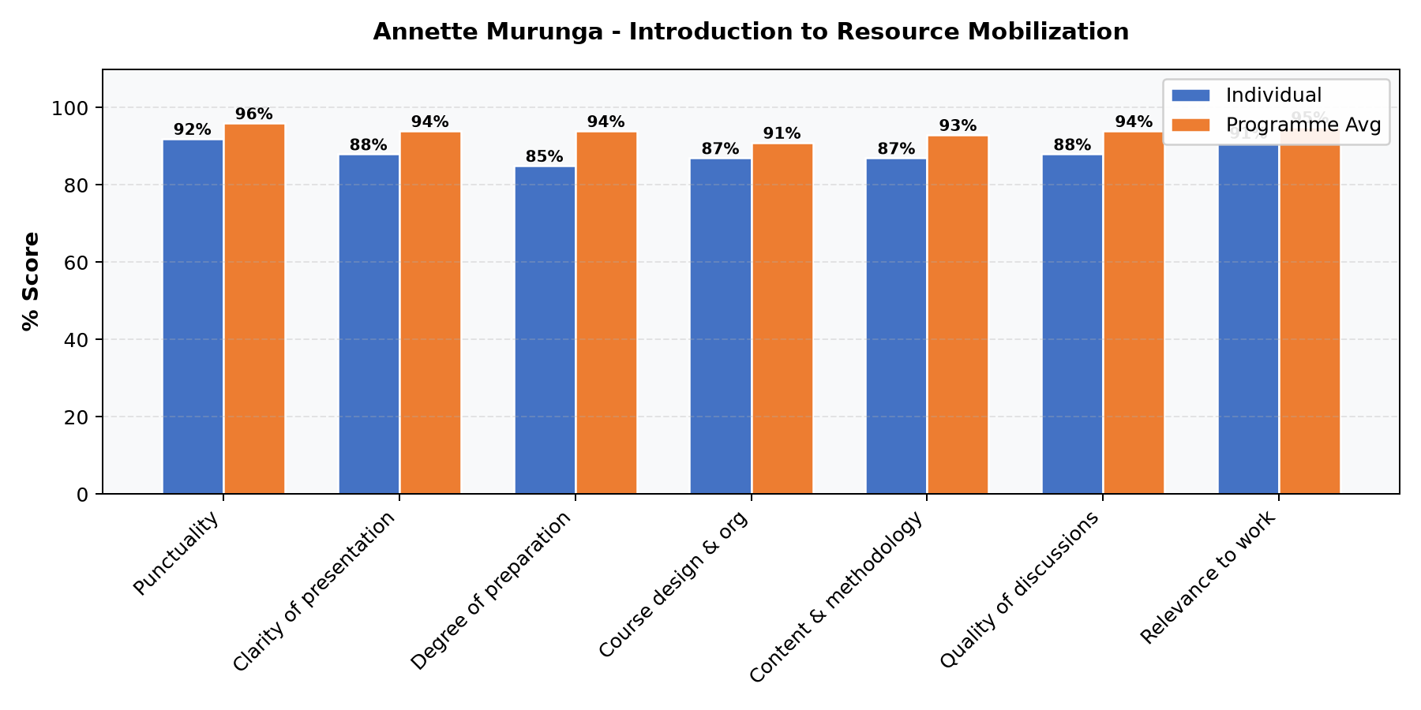

Comments & Feedback
- • Met my expectations
- • Ms Murunga set an excellent foundation to the course
- • The powerpoints could be improved in terns of font and color

Beatrix Masime - Introduction to Resource Mobilization
Evaluation Parameter | (%) Individual Score | (%) Programme Average
Punctuality | 96 | 96
Clarity of presentation | 91 | 94
Degree of preparation | 89 | 94
Course design & org | 86 | 91
Content & methodology | 90 | 93
Quality of discussions | 88 | 94
Relevance to work | 92 | 95
Average scores | 90 | 94

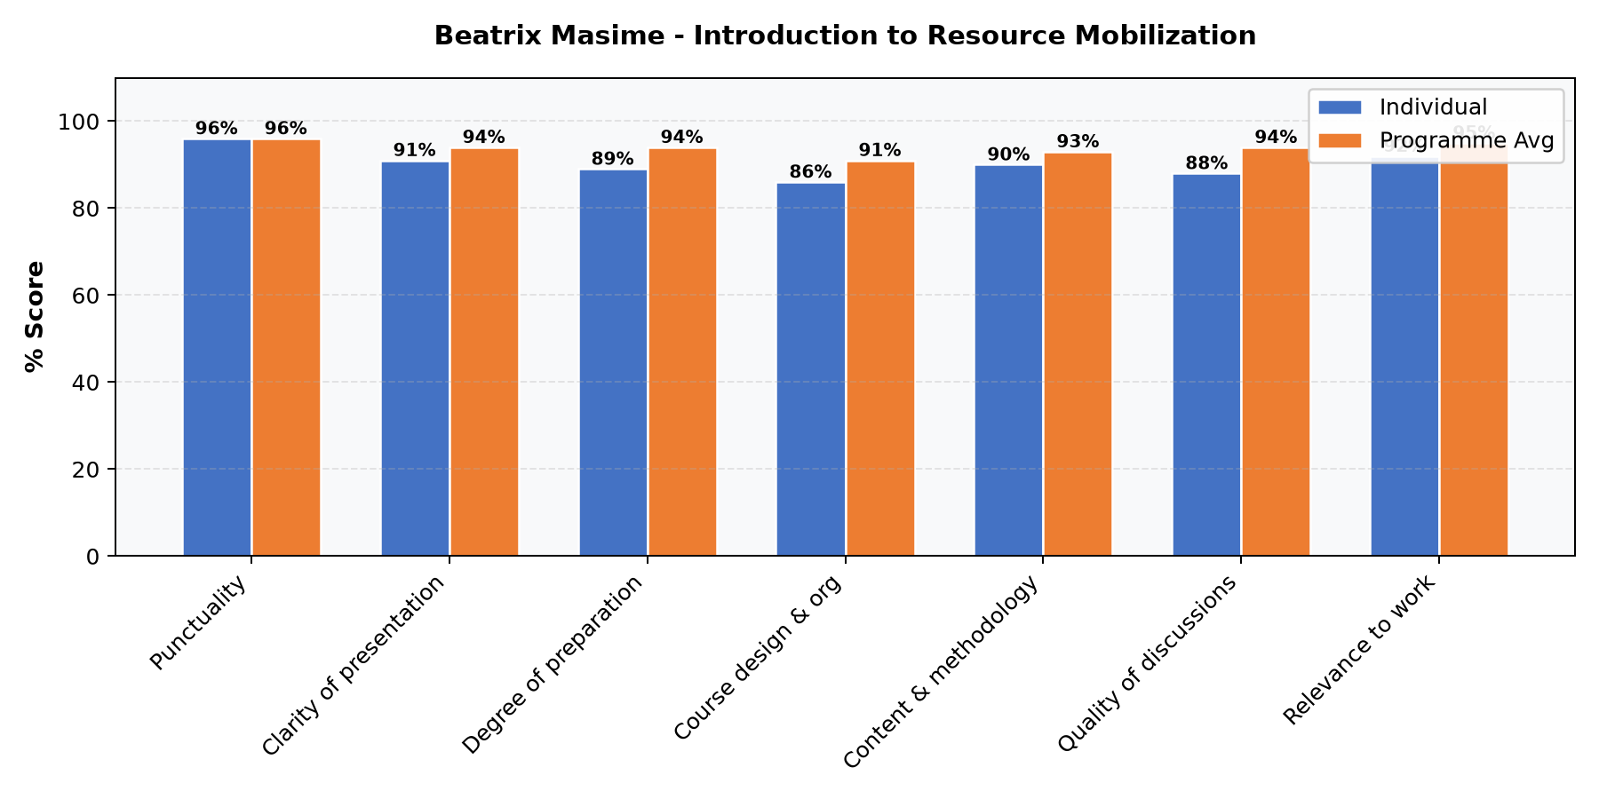

Comments & Feedback
- • Well delivered
- • In depth knowledge to the course shared and it was a wonderful opportunity to have the links to resource mobilization networks at the end of the class
- • Improve the powerpoints on color and font
- • The introduction to the course provided great insights about resource mobilization

Beatrix Masime - Managing donor relations Donor reporting
Evaluation Parameter | (%) Individual Score | (%) Programme Average
Punctuality | 100 | 96
Clarity of presentation | 100 | 94
Degree of preparation | 100 | 94
Course design & org | 94 | 91
Content & methodology | 97 | 93
Quality of discussions | 97 | 94
Relevance to work | 97 | 95
Average scores | 98 | 94

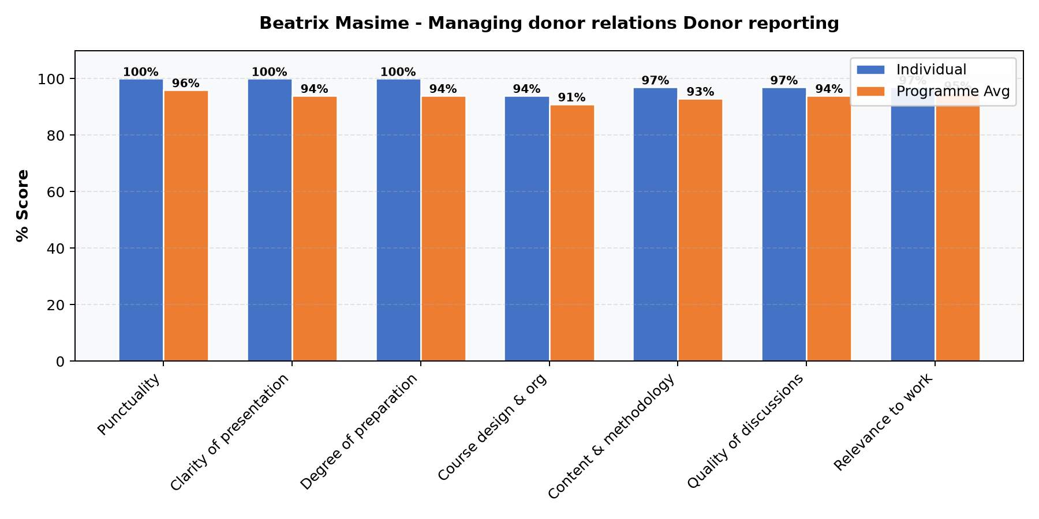

Comments & Feedback
- • Presentation was well thought out

Emmanuel Munyasia - Proposal development: Budgeting
Evaluation Parameter | (%) Individual Score | (%) Programme Average
Punctuality | 100 | 96
Clarity of presentation | 96 | 94
Degree of preparation | 96 | 94
Course design & org | 96 | 91
Content & methodology | 93 | 93
Quality of discussions | 96 | 94
Relevance to work | 96 | 95
Average scores | 96 | 94

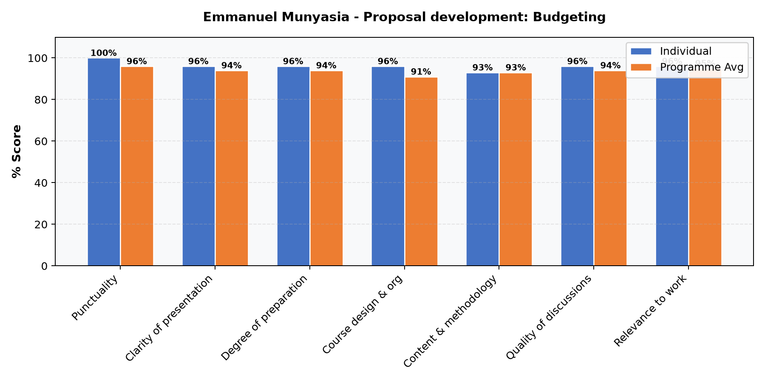

Comments & Feedback
- • Have deeper sessions on budgeting
- • Good trainers with knowledge

Leone Mawa - Proposal development: Understanding donor requirements and donor approaches to proposal development
Evaluation Parameter | (%) Individual Score | (%) Programme Average
Punctuality | 91 | 96
Clarity of presentation | 87 | 94
Degree of preparation | 91 | 94
Course design & org | 89 | 91
Content & methodology | 87 | 93
Quality of discussions | 87 | 94
Relevance to work | 93 | 95
Average scores | 89 | 94

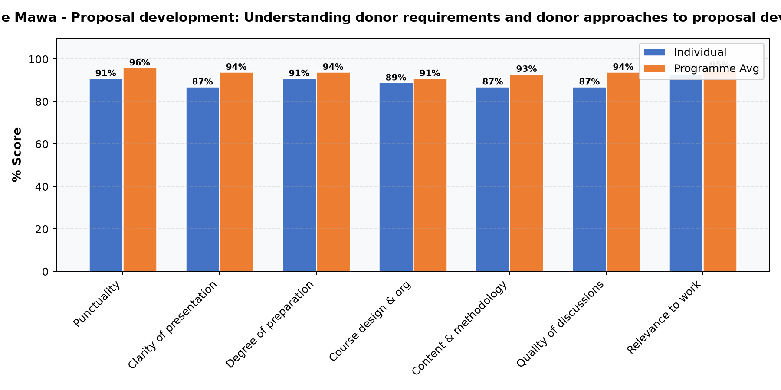

Comments & Feedback
No comments recorded.

Annette Murunga - Proposal development: Writing winning proposals
Evaluation Parameter | (%) Individual Score | (%) Programme Average
Punctuality | 93 | 96
Clarity of presentation | 93 | 94
Degree of preparation | 96 | 94
Course design & org | 96 | 91
Content & methodology | 98 | 93
Quality of discussions | 96 | 94
Relevance to work | 98 | 95
Average scores | 96 | 94

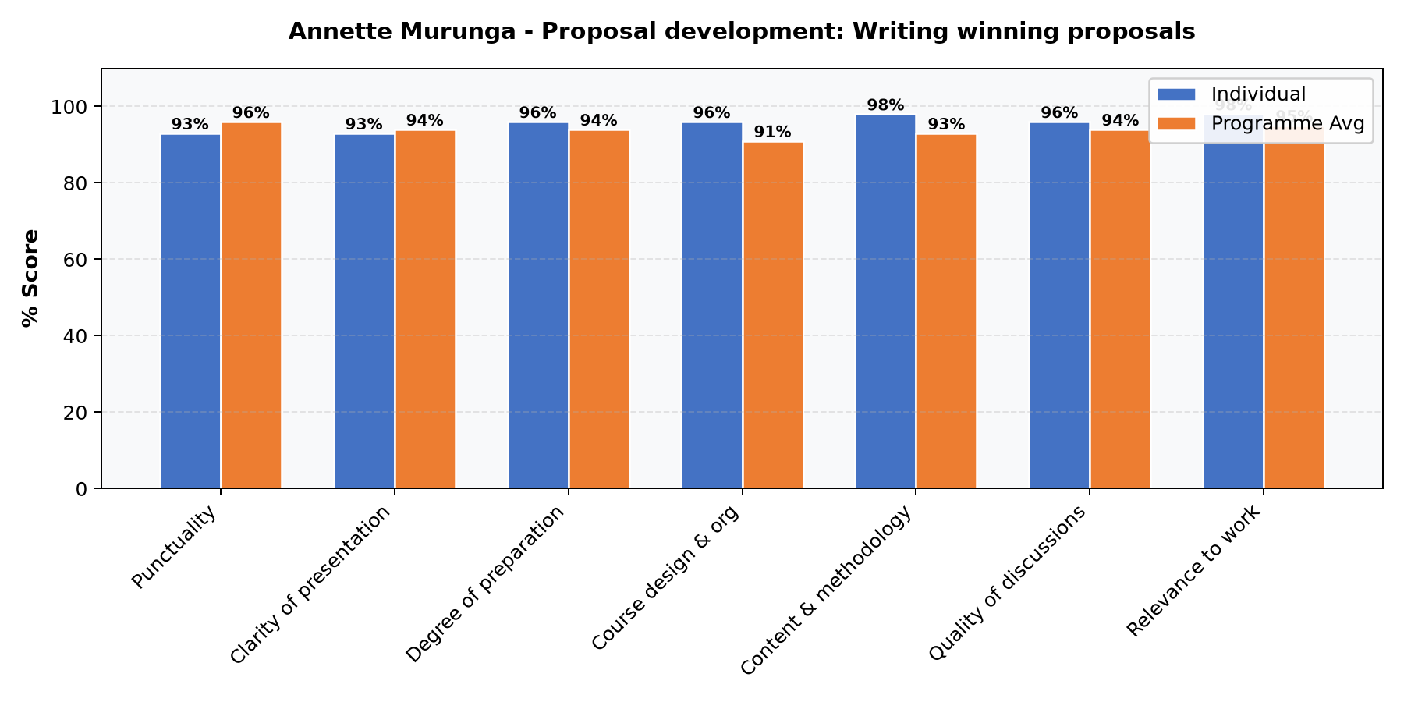

Comments & Feedback
No comments recorded.

Leone Mawa - Resource Mobilization Strategy || Tools for Fundraising
Evaluation Parameter | (%) Individual Score | (%) Programme Average
Punctuality | 89 | 96
Clarity of presentation | 89 | 94
Degree of preparation | 89 | 94
Course design & org | 85 | 91
Content & methodology | 87 | 93
Quality of discussions | 87 | 94
Relevance to work | 91 | 95
Average scores | 88 | 94

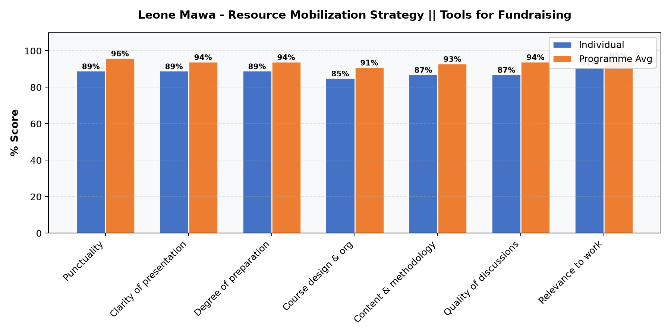

Comments & Feedback
- • The day seemed not well planned for. The afternoon session the faculty was tired and not well prepared
- • Alot of time is needed for this to help develop one for an organization.Consider allocating more time for this
- • Meet expectations
- • More time
- • Keep up

Leone Mawa - Submitting your proposal: Other obligatory requirements || Managing donor relations: Monitoring and evaluation
Evaluation Parameter | (%) Individual Score | (%) Programme Average
Punctuality | 100 | 96
Clarity of presentation | 100 | 94
Degree of preparation | 100 | 94
Course design & org | 91 | 91
Content & methodology | 97 | 93
Quality of discussions | 100 | 94
Relevance to work | 100 | 95
Average scores | 98 | 94

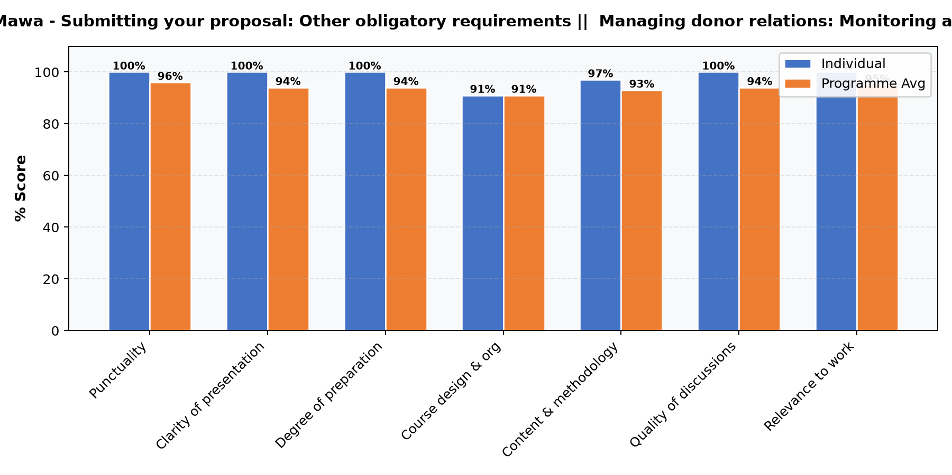

Comments & Feedback
- • Requires more time

Department Reports

Any other comments/suggestions

Comments & Feedback
- • The course was an eye opener
- • Please improve on the food

Areas found most relevant and practical to business

Comments & Feedback
- • Resource mobilization strategy formulation
- • Budgeting, proposal writing
- • Writing winning proposals
- • Proposal writing
- • Budget
- • Strategy alignment
- • Budget negotiation budgeting
- • M&E

Client experience (Edwin Papaa)
Evaluation Parameter | (%) Score
Timeliness | 100
Communication skills | 98
Response to feedback and participant needs | 96
Organization and attention to detail | 98
Quality of service/professionalism | 96
Timely distribution of program materials | 98
Average score | 98

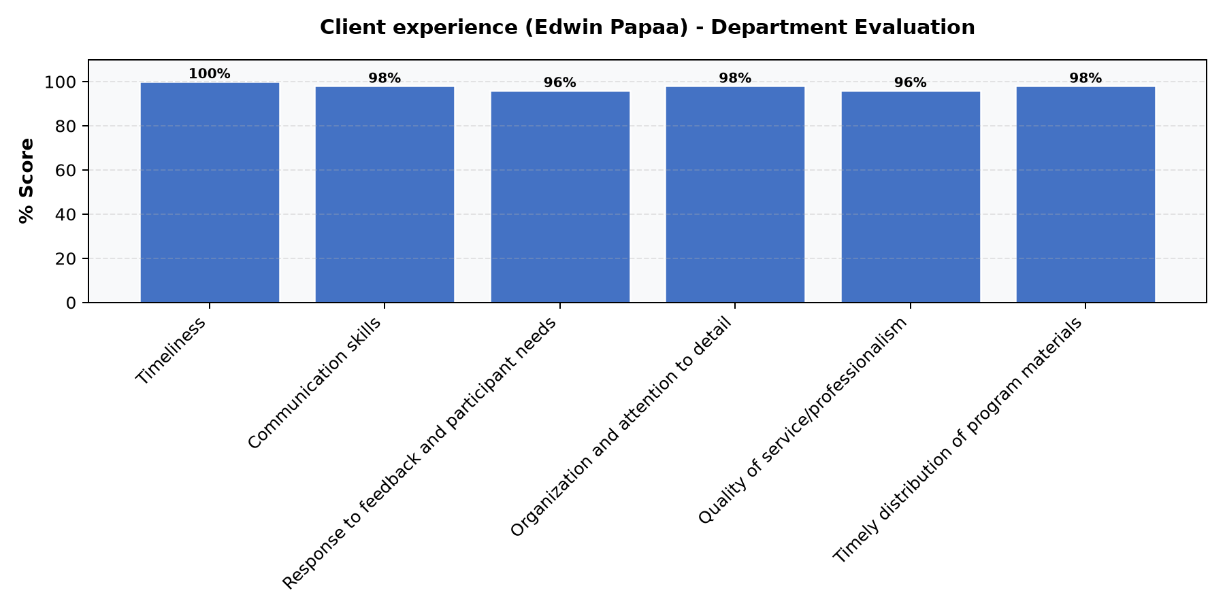

Comments & Feedback
No comments recorded.

General Comments

Comments & Feedback
- • It was interesting and relevant presentations
- • Great first day! Surpassing expectations
- • I think clear marking on Washrooms per floor. Took me about 10 minutes to figure out the gents in the other floor when the basement one was being cleaned. Otherwise all was great.
- • Need for more time and information especially on types of funding for organizations
- • Looking forward to learning more about the course
- • Consider switching faculty to avoid exhaustion in a day
- • Let's have healthy breaks even for 2mins to stretch. Too much sitting makes the lesson boring
- • More time
- • Great presentation
- • Great engagement during class discussions with practical examples and experiences
- • Appreciated
- • Impressive

Overall Evaluation
Evaluation Parameter | (%) Score
Overall program evaluation | 92
Average score | 92

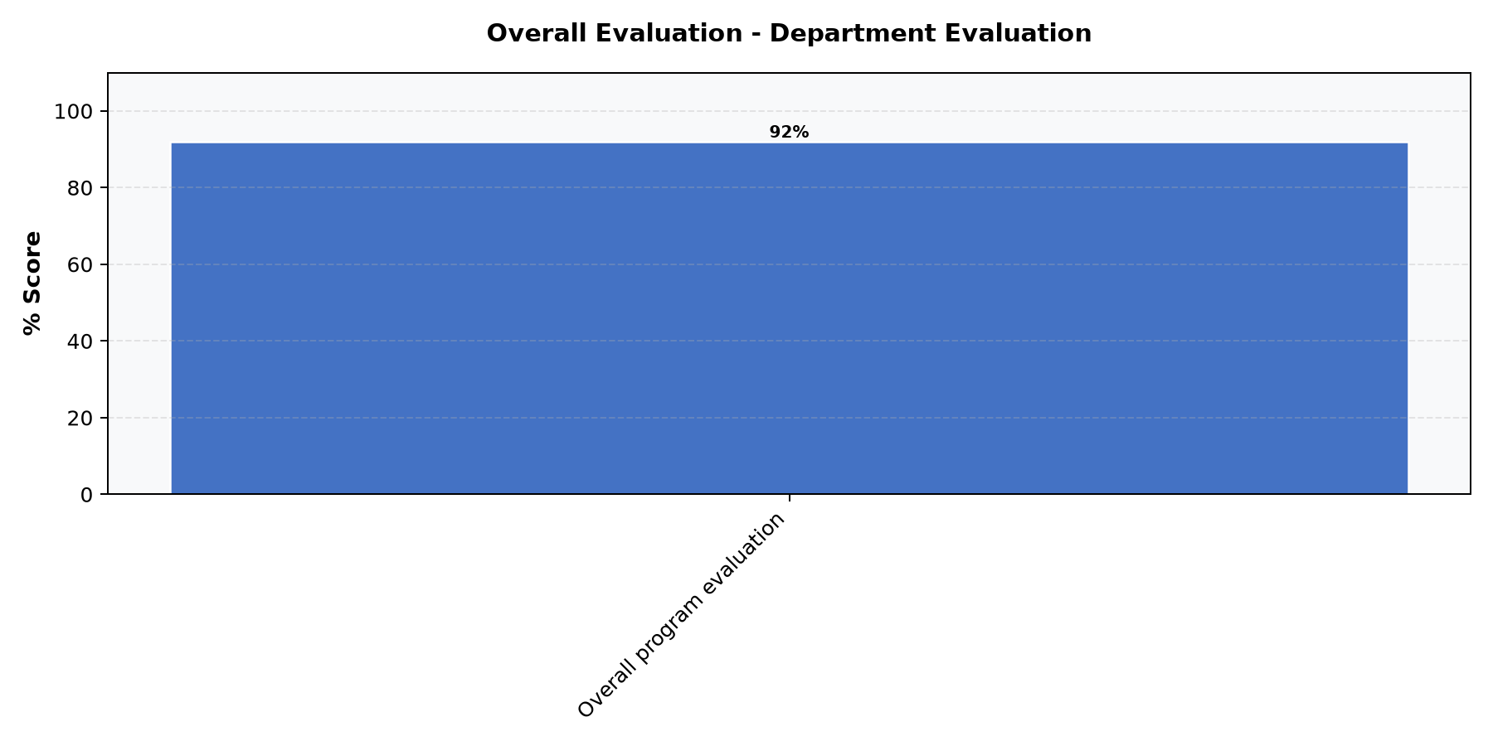

Comments & Feedback
No comments recorded.

Programme Administration: Cafeteria
Evaluation Parameter | (%) Score
Overall Quality of food/Service | 90
Professionalism of Cafeteria Staff (Attitude of the serving staff,Communication etc) | 94
Variety of food | 90
Average score | 91

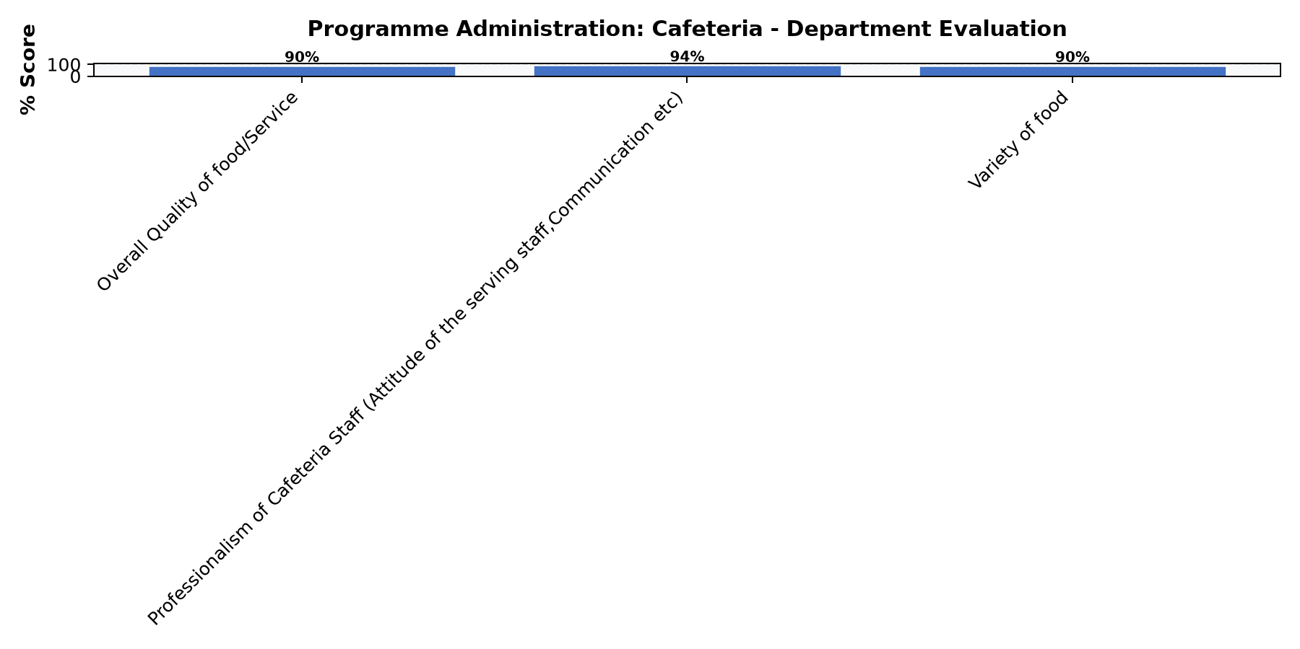

Comments & Feedback
- • The food variety is wanting, quality also moderate
- • Have more time to discuss fundraising

Programme Administration: House Keeping (General Cleanness of SBS)
Evaluation Parameter | (%) Score
Housekeeping staff is responsive to your needs. | 94
Quality of the tasks completed by housekeeping staff. | 92
Overall satisfaction with Housekeeping Services. | 92
Average score | 93

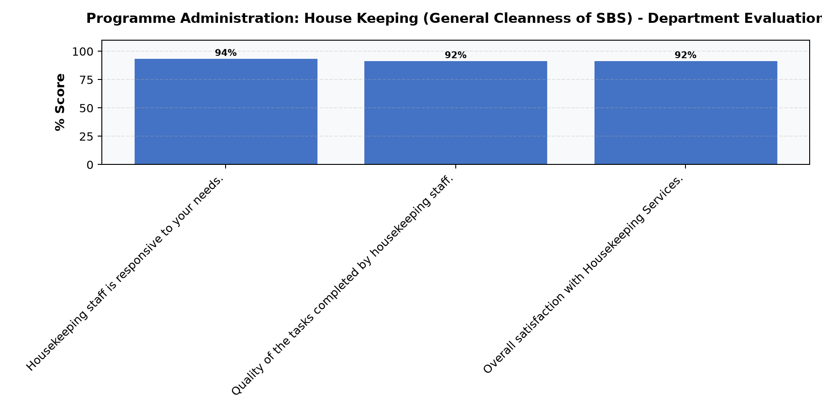

Comments & Feedback
No comments recorded.

Programme Administration: Security & Other Amenities
Evaluation Parameter | (%) Score
Courtesy of the security guards | 96
Security and Safety measures adopted by the school overall | 98
Effectiveness of the Security services | 98
Average score | 97

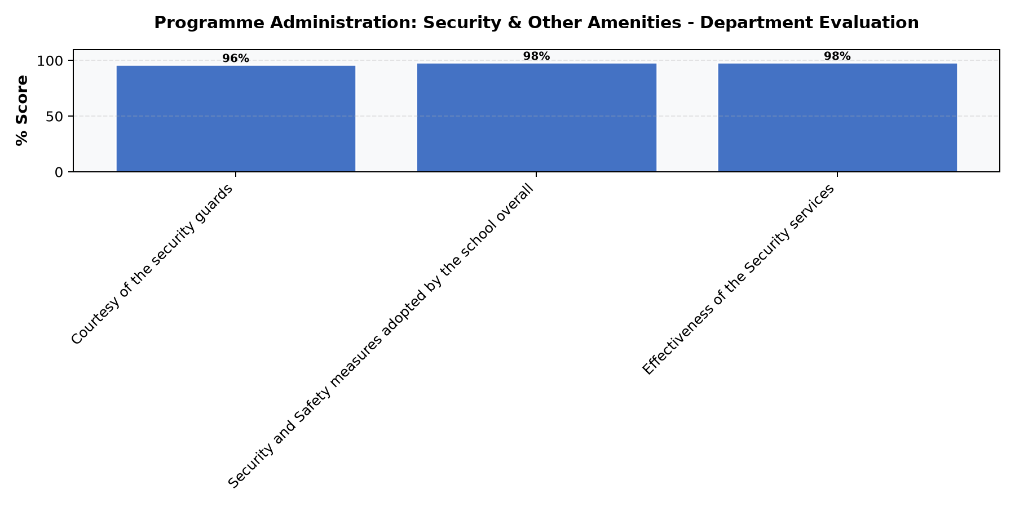

Comments & Feedback
No comments recorded.

Teaching methods applied enjoyed/ learnt from the most

Comments & Feedback
- • One on one and group work
- • Plenary discussions, use of practical examples
- • Group work
- • Presentation
- • Group discussions

Topics recommended to be expanded or improved in this module/unit

Comments & Feedback
- • Resource mobilization for Government funded programs
- • M&E
- • Budget
- • Proposal development and reporting
- • Budgeting
- • M&E, BUDGETING

What are your key learning from the sessions conducted?

Comments & Feedback
- • Continuous development and improvement is critical in the resource mobilization space
- • Learning does not stop, more research is needed
- • Donor intelligence Donor visibility Compliance Negotiations
- • Data is key to good RM venture
- • Budget Negotiations Proposal review Partnerships and contract management
- • DEVELOPMENT OF WINNING PROPOSALS

What learnings are you taking away from this module?

Comments & Feedback
- • Resource mobilization strategy is key in the success of resource mobilization
- • It is essential to develop a resource mobilization strategy even when you don’t plan to fundraise in the short term
- • Need to institutionalise RM in my organisation
- • Proposal writing
- • 1. Budget negotiation skills 2. Partnerships 3. Budgeting

